**TASK-3**

CSS

* Complete CSS :

[CSS CodeWithHarry](https://www.youtube.com/watch?v=Edsxf_NBFrw&t=19s)

* CSS Flexbox :

[Flexbox CSS In 20 Minutes](https://www.youtube.com/watch?v=JJSoEo8JSnc)

* CSS Grid :

[CSS Grid Layout Crash Course](https://www.youtube.com/watch?v=jV8B24rSN5o)

* CSS Animations and Transitions :

[CSS3 Animation & Transitions Crash Course](https://www.youtube.com/watch?v=zHUpx90NerM)

* Responsive web design using CSS :

- [CSS Responsive Web Design Introduction](https://www.w3schools.com/css/css_rwd_intro.asp)

- [CSS Media Queries Tutorial for Responsive Design](https://www.youtube.com/watch?v=j1AhSWFcZpg)

Bootstrap :

- [Bootstrap Tutorials](https://www.youtube.com/watch?v=w1pA3NqHIWA&list=PLJwQcG-us9FTqeQGLngMpmqWLZtFbWkVS&index=4)-Angela Yu

- [Bootstrap Tutorials-CodeWithHarry](https://www.youtube.com/watch?v=vpAJ0s5S2t0)

- [Bootstrap · The most popular HTML, CSS, and JS library in the world.](https://getbootstrap.com/)

Tailwind :

- [Tailwind C SS Crash Course](https://www.youtube.com/watch?v=UBOj6rqRUME)

- <https://tailwindcss.com/>

Task :-

Responsive landing page of Nature and its beauty using HTML and CSS. You can also use Bootstrap or Tailwind.

A sample of Landing Page given below for your reference (Be creative you can use your own image, colors and make your landing page accordingly.)

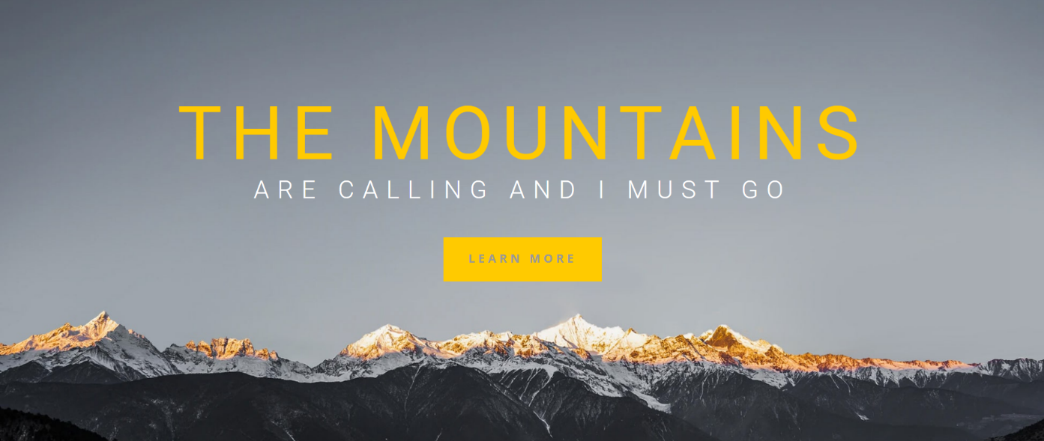

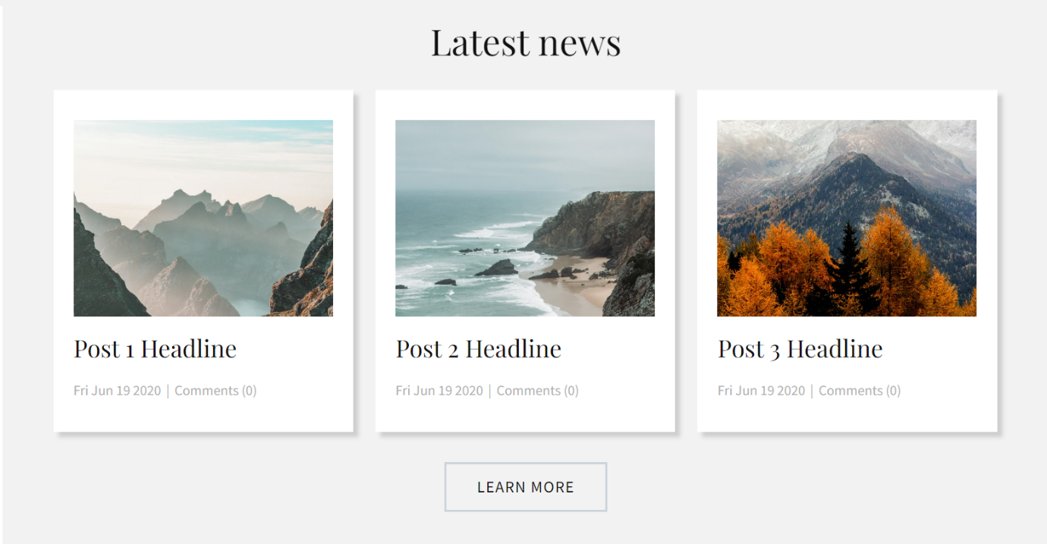

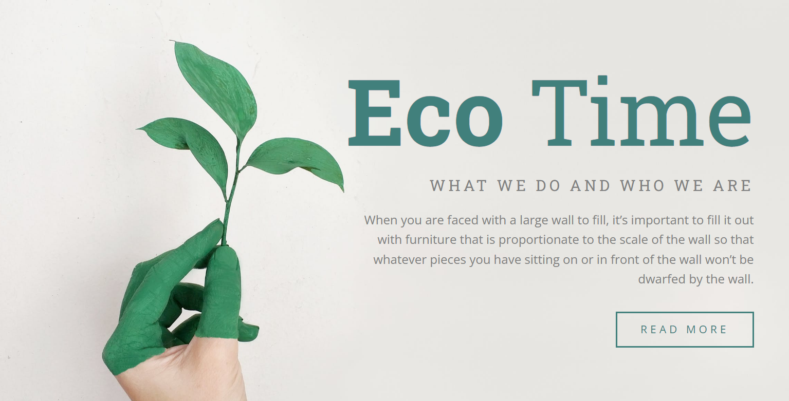



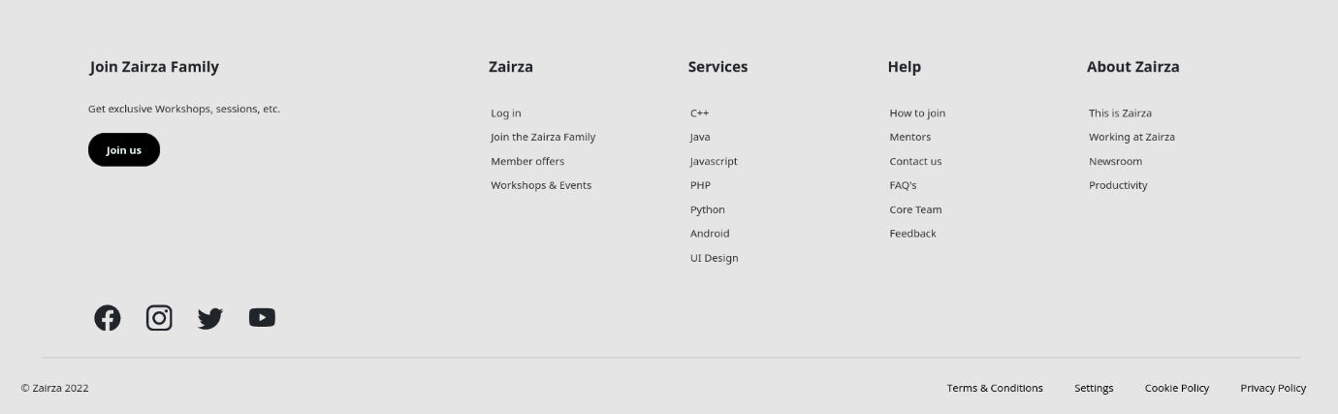

**NOTE: Submit all the tasks with a GitHub repo link and a hosted link.**

Now if you have gone through all these resources and completed all the tasks then you can go through the topics which we would be covering in next week :

* Javascript
* ES6 Modern Javascript
* DOM(Document Object Model)